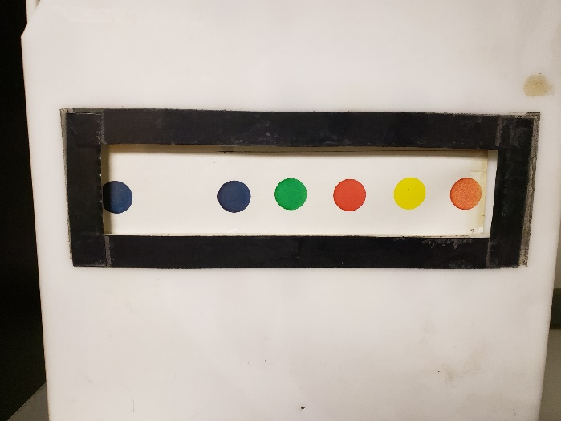
The perceptual speed test at 4 relied on color images being rotated through a chamber, with the child pointing to the correct answer:
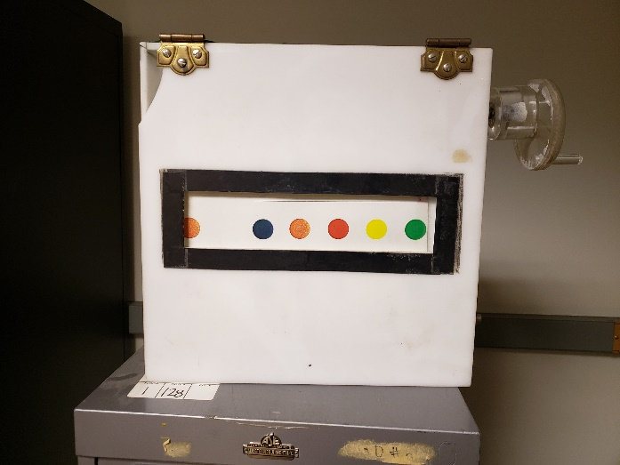
The Identical Pictures test at age 4 relied on the same rolled stimuli, but had shapes instead of colors:
