Developmental Models

Lindon Eaves, Nathan Gillespie & Brad Verhulst
Thu Mar 10, 2016 1:30pm – 3pm Mountain Time


Why run longitudinal models?
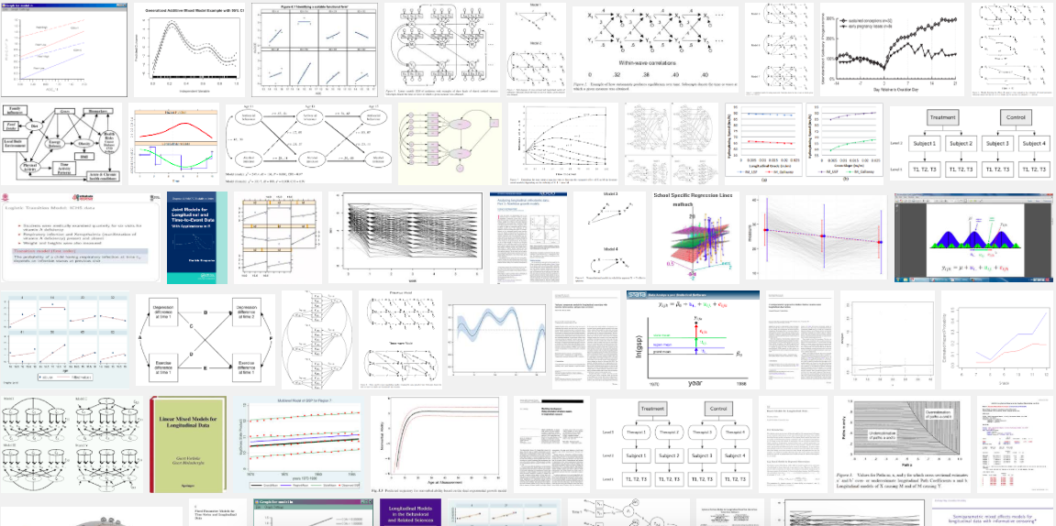

Why run longitudinal models?

Map changes in the magnitude of genetic & environmental influence across time

ID enduring versus time dependent genetic or environmental risks

Improve power to detect A, C & E
Various models for analysing longitudinal data

1. Cholesky Decomposition
2. Latent growth curve model
3. Auto-regression model
4. Dual Change Score model

Models imply that you look at your variance-covariance matrix & have a theory about the nature of change

2
3
1
Atheoretical longitudinal model

1. Cholesky Decomposition

Advantages
- logical: organized such that all factors are constrained to impact later, but not earlier time points
- requires few assumptions: can predict any pattern of change

Disadvantages
- atheoretical: no explicit hypothesis of change. Describes patterns of change without accounting for them in terms of one or more simpler and, potentially more informative theoretical possibilities

Theoretical longitudinal models
After inspecting your observed variances-covariances in your repeated measures:

- UNFOLDING Individual genetic and/or environmental differences in inherent growth patterns with age - Latent growth curve effects

- ACCUMULATION of individual genetic and/or environmental differences, which are more of less persistent - Autoregressive effects

- Latent growth curve model + Auto-regression model (“Dual Change Score model:”)

NB: INSPECT DATA

1. Latent growth curve model
AKA ‘‘random regression’’, ‘‘hierarchial mixed’ or ‘‘latent growth curve” models”

What does the LGC model predict?

1. Variation in latent true scores at each time point is a function of where you begin, or what you begin with, in terms of individual genetic and environmental differences….

2. Variation in latent true scores at each time point is also a function of UNFOLDING individual genetic and environmental differences, over time,

Unfolding may involve linear and non-linear rates of change.
Latent growth modelling
Developmental change = UNFOLDING of inherent, random genetic & environmental differences in the level & rates of change in behavior over time

Model corresponds to special cases of the factor model in which factor loadings from the level (intercept) & change factors are functions of the coefficients of a priori contrasts on the levels of age at which the repeated measures were taken

Latent growth modelling
Recap – common pathway
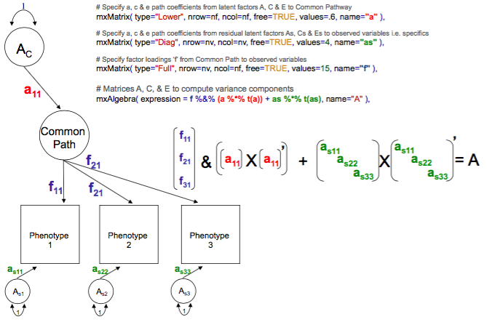

Latent growth modeling
Recap – common pathway
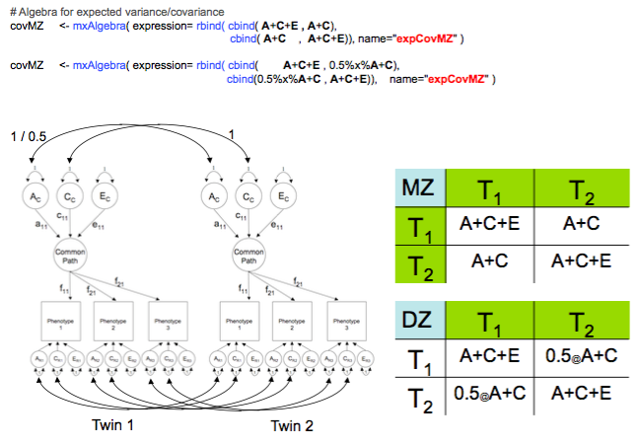

Latent growth modelling
Add another latent factor fix the factor loadings

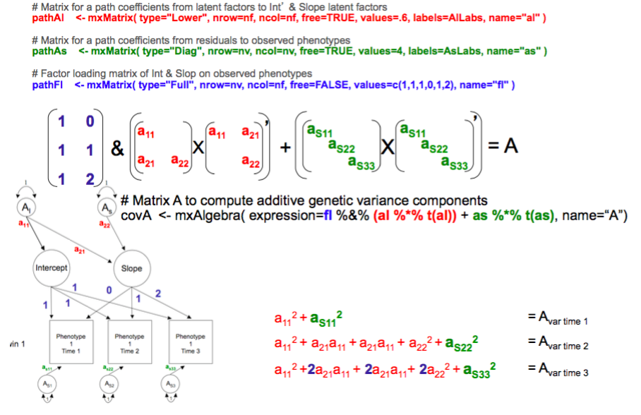
Latent growth modelling

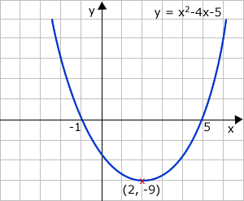
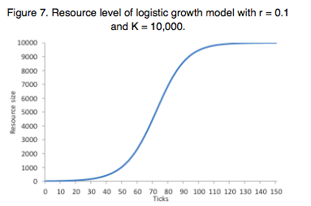
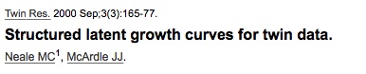
2. Auto-regression modelling
AKA “simplex modelling” and “Sh%t-St%cks model”

Example means
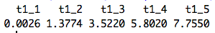
Example covariation matrix correlation matrix
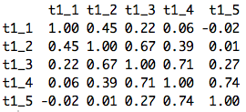
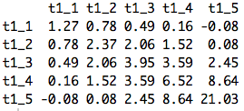

Cross-temporal correlations within subjects arise because time specific sources of individual differences are more or less persistent time, and may, ACCUMULATE during development.

Giving rise to a developmental increase in genetic and/or environmental variance, and increased correlations between adjacent measures

Auto-regression models

Enables partitioning of variation at each time point into:

- Transient genetic & environmental risks unique to each occasion
- Persistent, enduring genetic & environmental risk factors

Examples?

- Snow-ball
- Vocabulary acquisition
- Emotional baggage
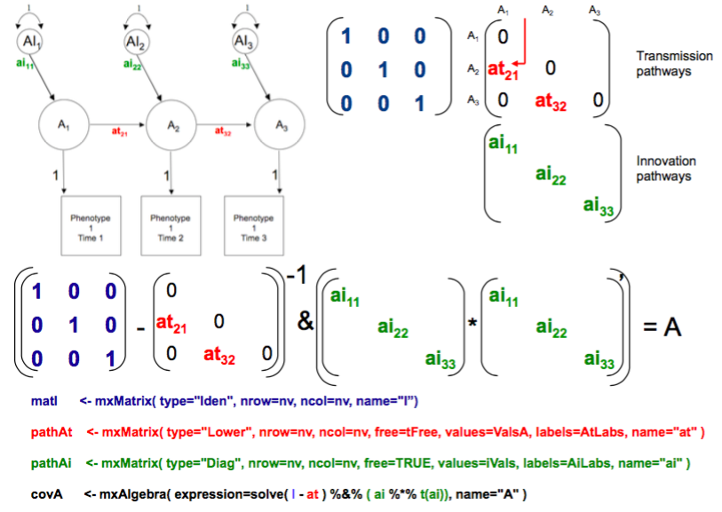
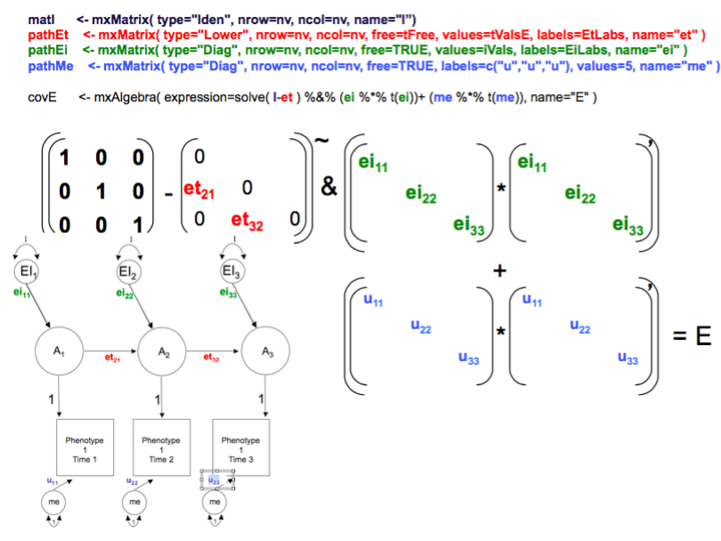
Auto-regressive model examples
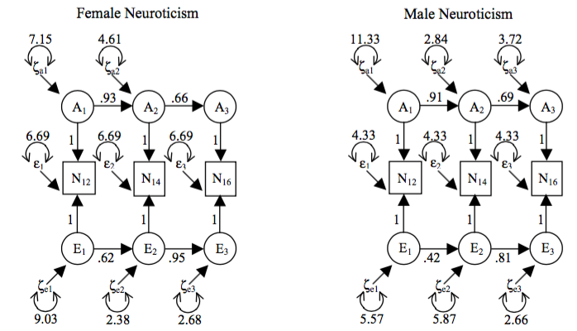
Auto-regressive model examples
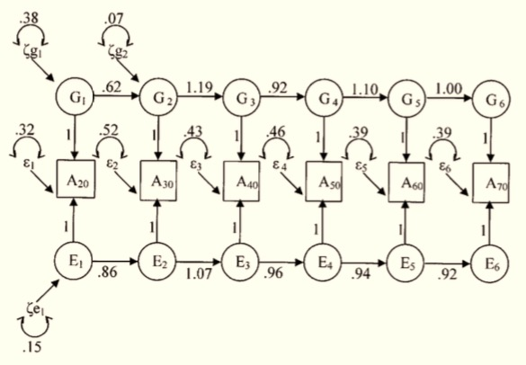
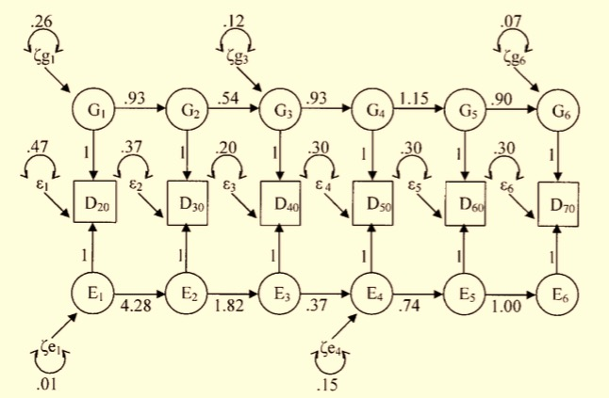
Dual Change Score model
Latent growth curve model + Auto-regression model

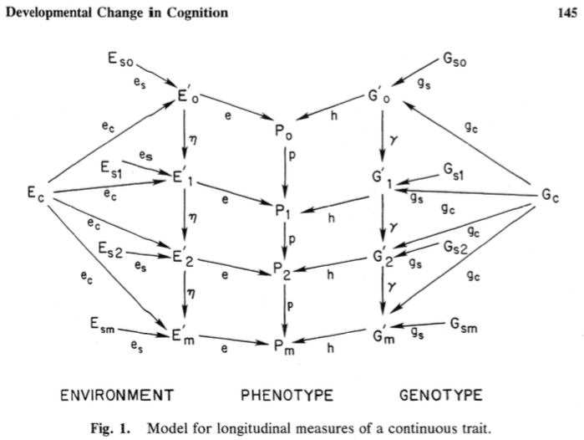
Dual Change Score model

Dual Change Score model
Lisrel model (Jöreskog & Sörbom, 1996) to estimate expect covariance:
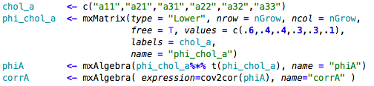
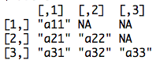

Pracatica
Dual_change_score_model.R

