Small tutorial of KGG for Gene-, Protein-protein interaction- and Pathway-based association analysis
Miaoxin Li ( mxli@hku.hk)

Input data:
- Meta-analysis test statistics of Crohn's disease originally downloaded from (http://www.broadinstitute.org/~jcbarret/ibd-meta/)
CrohnMetaPValueSetHg17Chr1.txt
- Known risk gene list of Crohn's disease
CrohnCandidateGeneSet.txt

Reference data to account linkage disequilibrium (LD) from 1000 Genomes Project
1kg.phase1.v3.shapeit2.eur.hg19.chr1.vcf.gz

Operations:
- Copy the KGGSample folder of the miaoxin/IBG2013/KGG/ into your folder.
- Create a KGG project : Project->Create Project
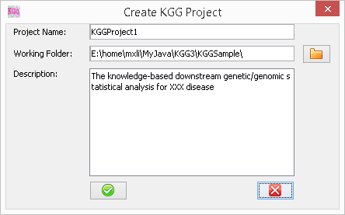
- Import original association file (load statistics or p values): Data->Load P value file
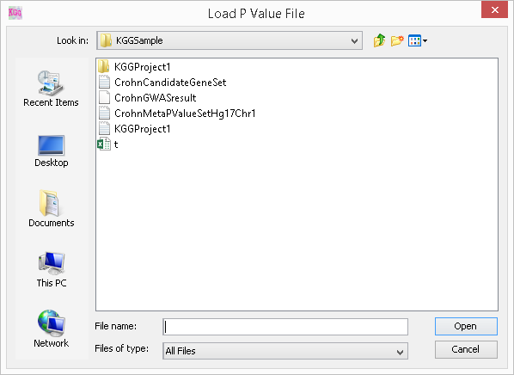
- Load candidate genes (Susceptibility genes almost established for a disease): Data->Define Candidate Genes
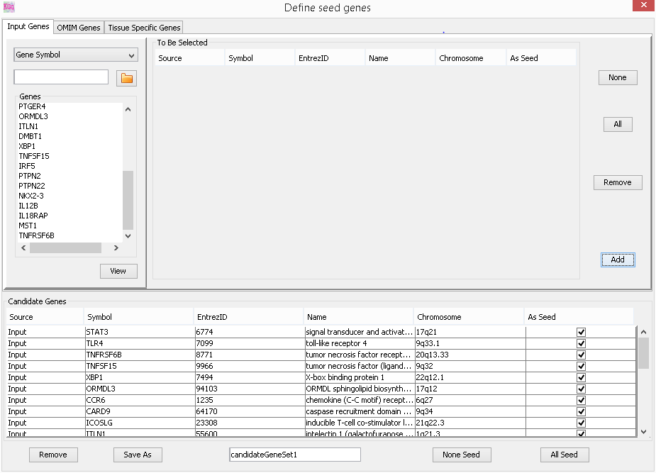
- Build an analysis Genome(~2min): Data->Build analysis genome
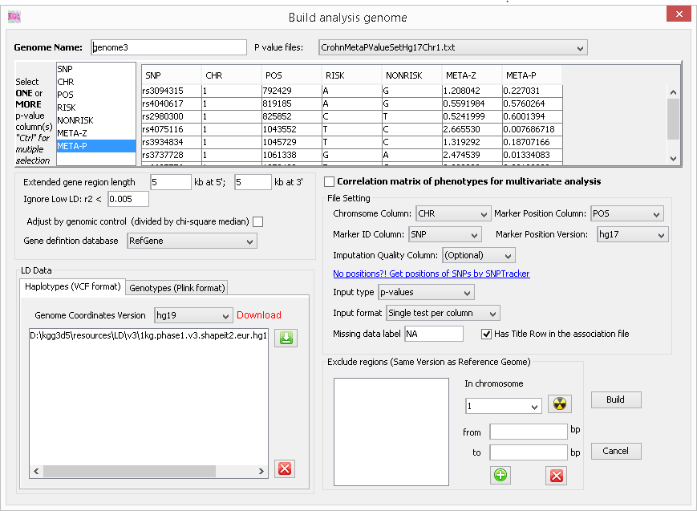
- Gene-based association analysis by GATES (~10sec.) Gene->Univariate association test
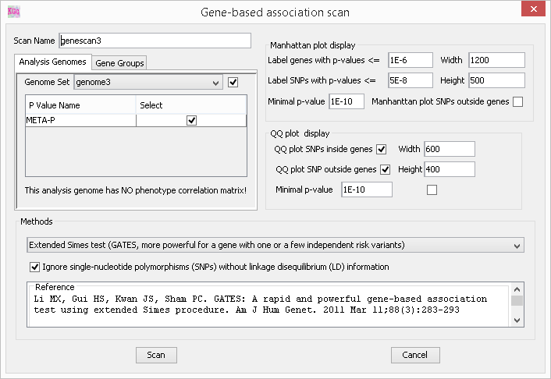
- Gene-based association analysis by HYST(~10sec.) Gene-> Univariate association test
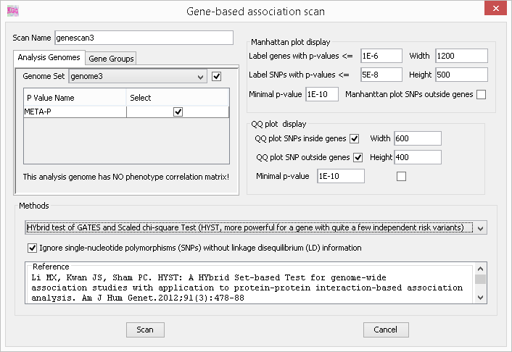
- View and export gene-based association p-values and their SNPs: At each gene scan -> Show: Detailed Results
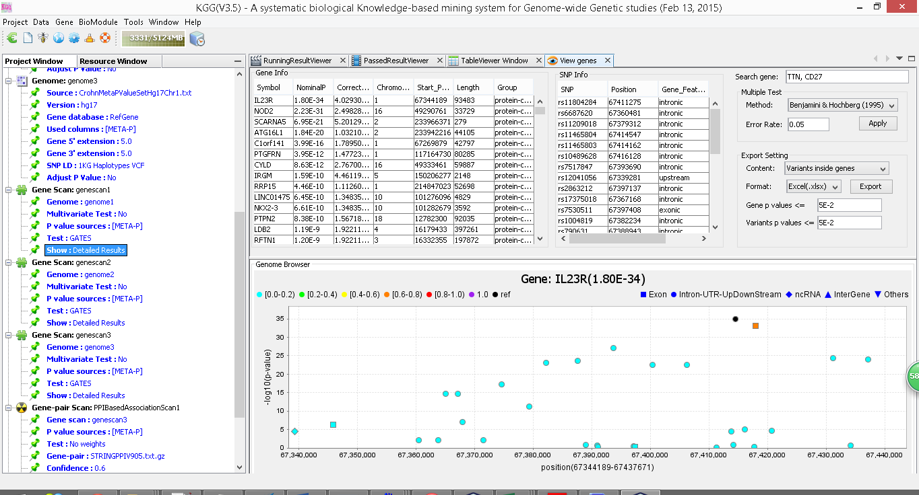
- View LD structure of SNPs within a gene: Gene->LD Plot
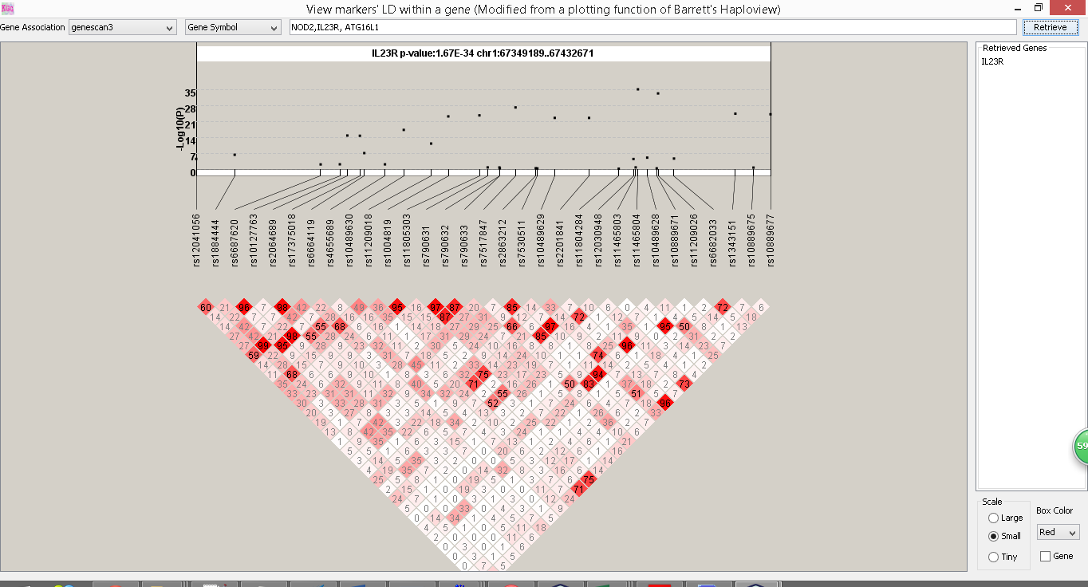

- Protein-protein interaction-based association analysis by HYST (~1 min.) BioModule->Gene-pair-based association scan
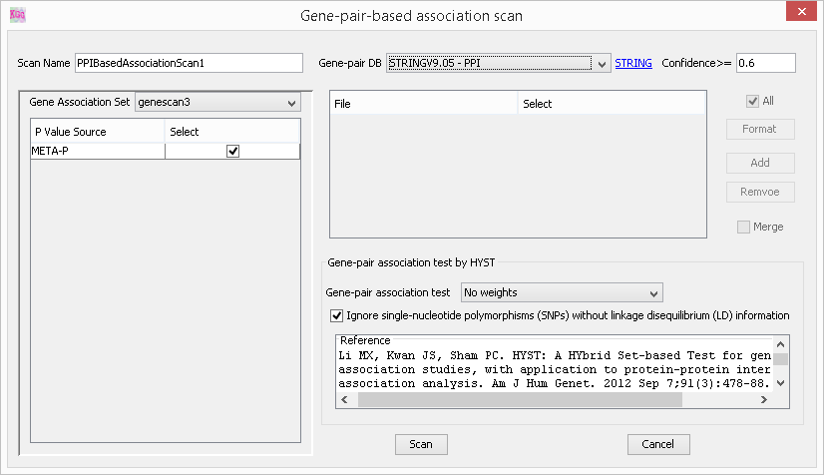
- View protein-protein interaction-based association results At each Gene-pair Scan -> Show: Detailed Results
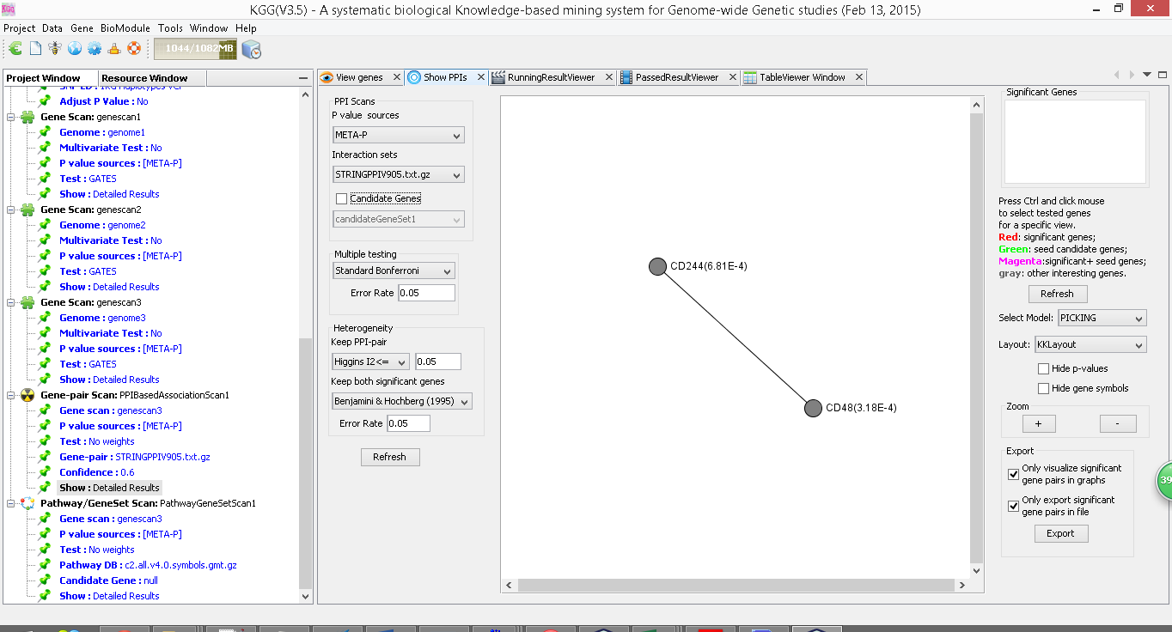

- Pathway gene set-based association analysis by HYST (~1 min.) BioModule -> Pathway-based association scan
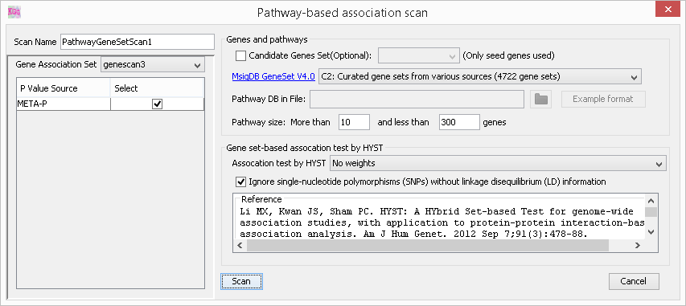

- View pathway-based association results At each Pathway/GeneSet scan -> Show: Detailed Results
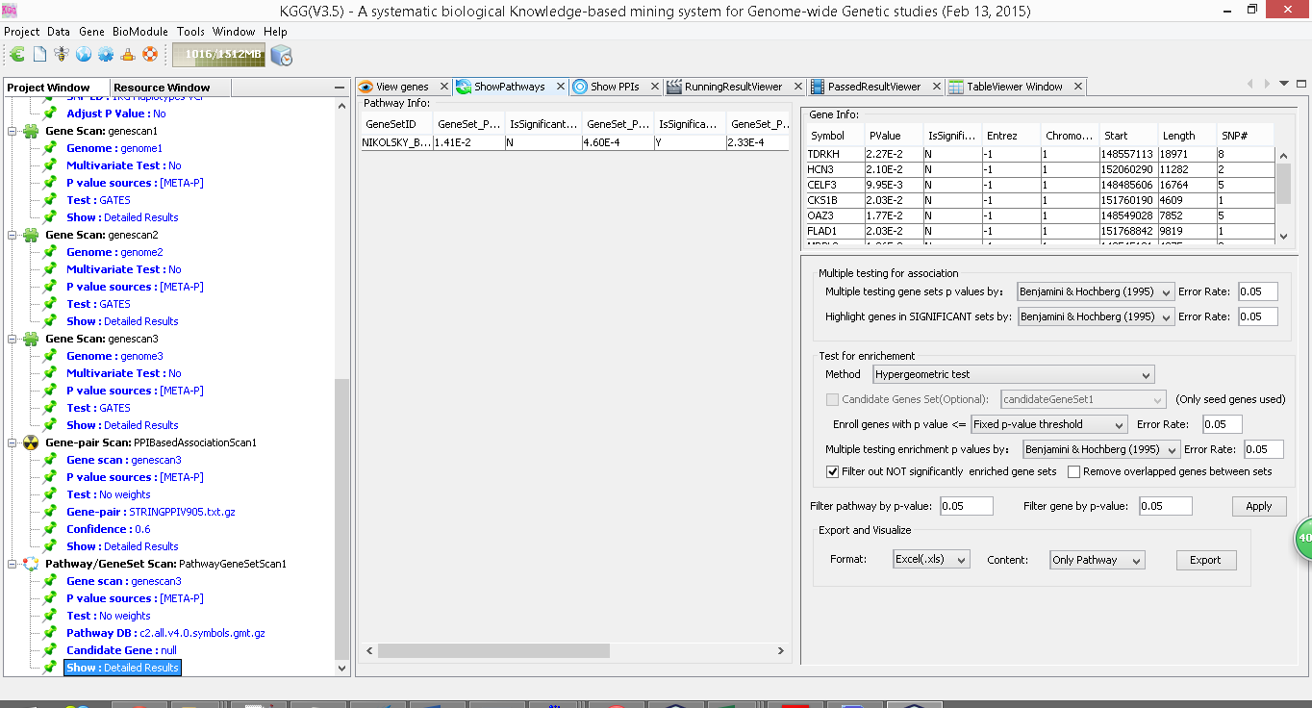

Multivariate gene-based association test
Input data:
Nine quantitative metabolic traits measured in the population-based NFBC1966 (N=4763; Sabatti et al., 2009), raw genotypes obtained from dbGAP were to calculate p-values of each SNP for each trait.
- 9MetabolicPhenotypesPhg19.txt
Correlation matrix of the 9 traits
- 9MetabolicPhenotypesCorr.txt

Reference data to account linkage disequilibrium (LD) from 1000 Genomes Project
1kg.phase1.v3.shapeit2.eur.hg19.chr[1..X].vcf.gz

- Build analysis genome with phonotype correlation Data->Build analysis genome
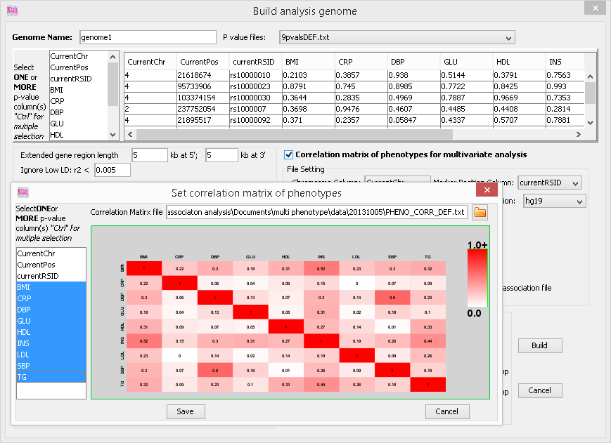
- Multivariate gene-based scan Gene->Univariate association test
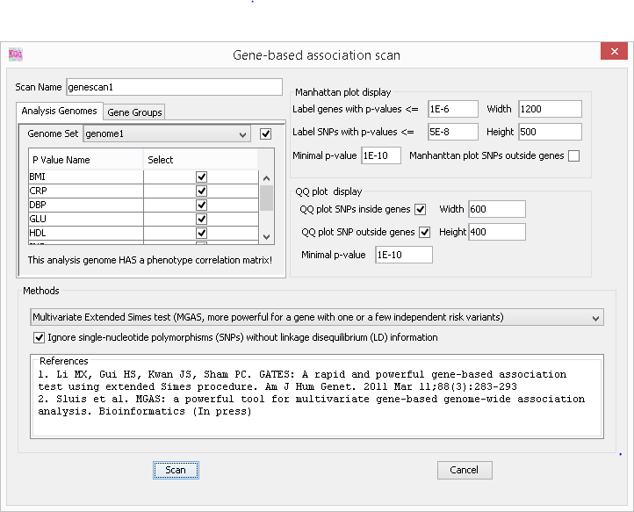
Estimate the power of set-based tests
- Estimate the power of set-based tests: Tools->Gene-pair-based association scan
