Small tutorial of KGG for Gene-, Pathway and Protein-protein interaction-based association analysis
Miaoxin Li ( mxli@hku.hk)

Input data:
- Meta-analysis test statistics of Crohn's disease (http://www.broadinstitute.org/~jcbarret/ibd-meta/)
CrohnMetaPValueSetChr1.txt
- Known risk gene list of Crohn's disease
CrohnCandidateGeneSet.txt

Operations:
- Copy the KGGSample folder of the miaoxin/IBG2013/KGG/ into your folder.
- Create a KGG project : Project->Create Project
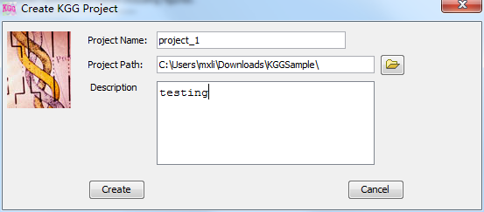
- Import original association file (load statistics or p values): Data->Import Original Association File
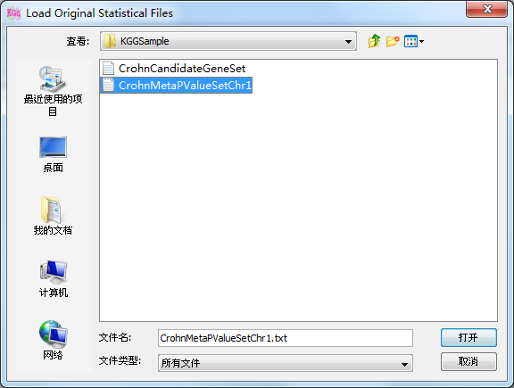
- Load candidate genes (Susceptibility genes almost established for a disease): Data->Define Candidate Genes
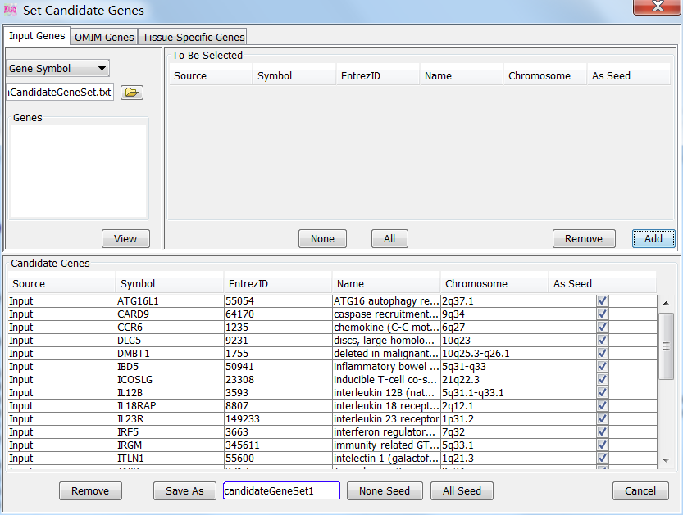
- Build an analysis Genome by RSID (~2min): Data->Build Analysis Genome by RSID
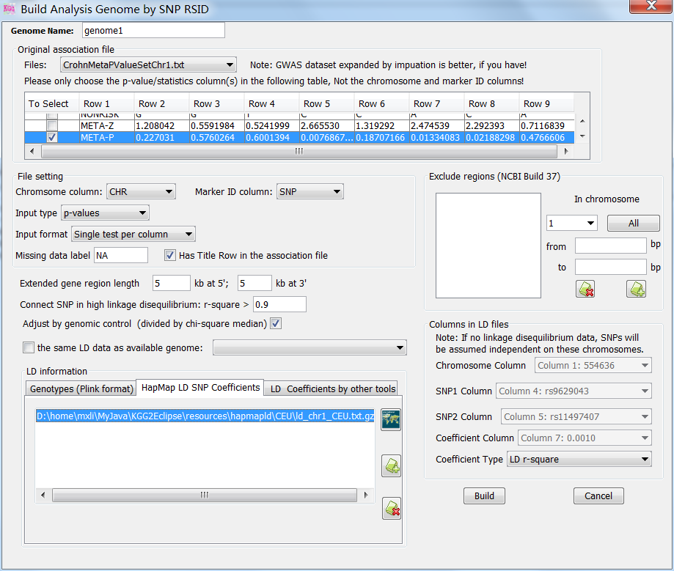
- Gene-based association analysis by GATES (~10sec.) Gene->Association Scan
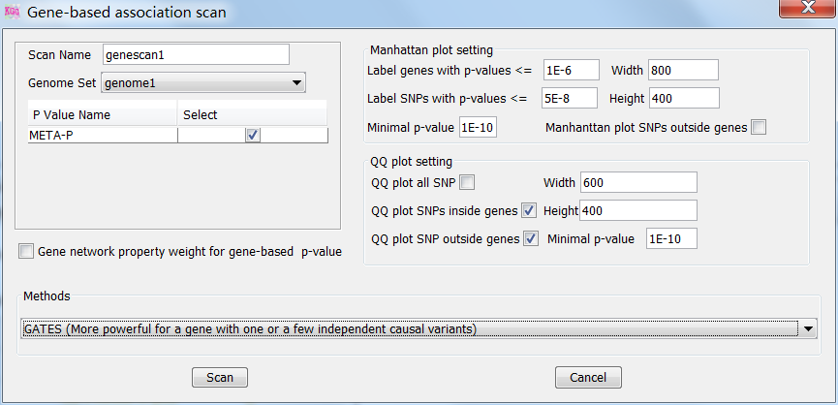
- Gene-based association analysis by HYST(~10sec.) Gene->Association Scan
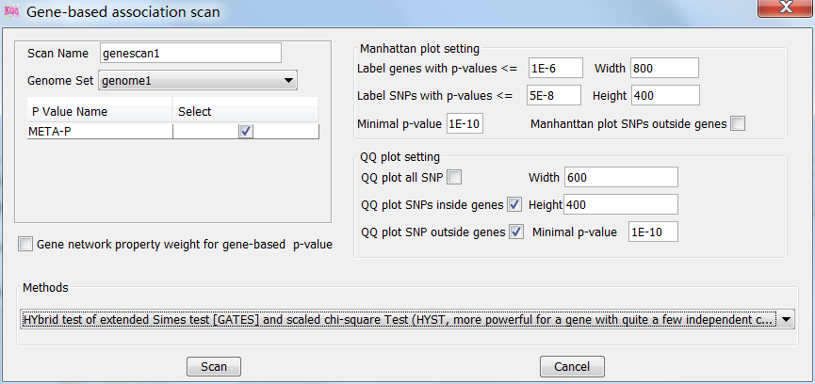
- Export gene-based association p-values and their SNPs: Gene->Annotation & Export
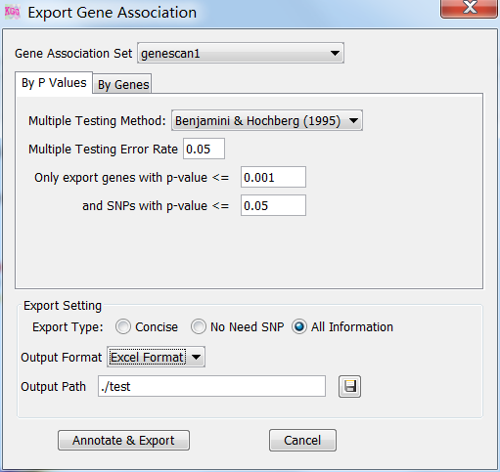
- View LD structure of SNPs within a gene: Gene->LD Plot Annotation
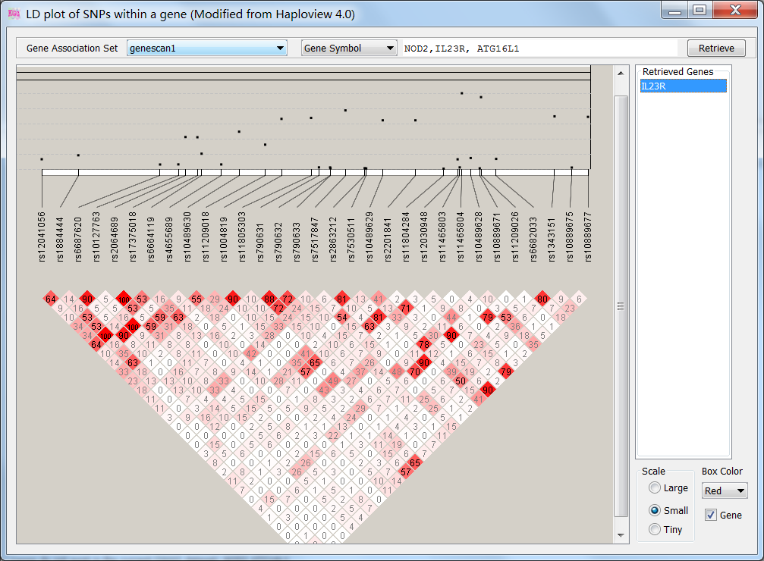
- Pathway gene set-based association analysis by HYST (~1 min.) Module-> Pathway gene set-based Association
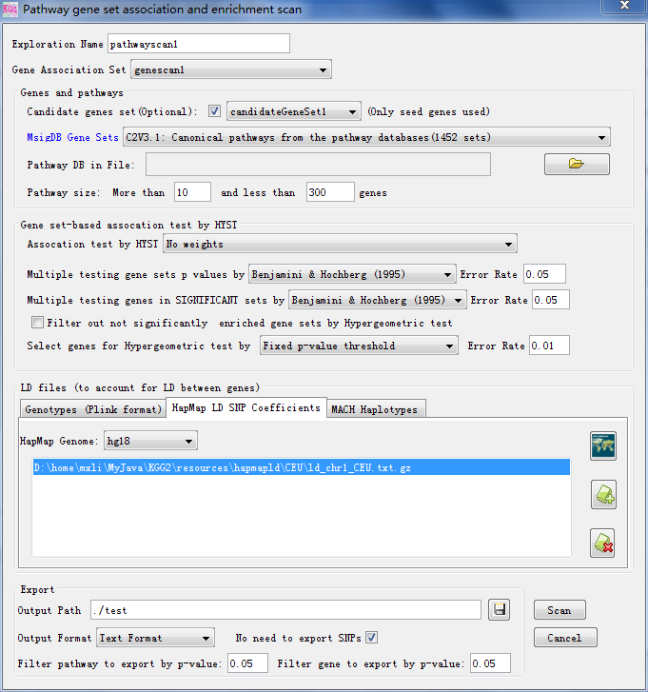
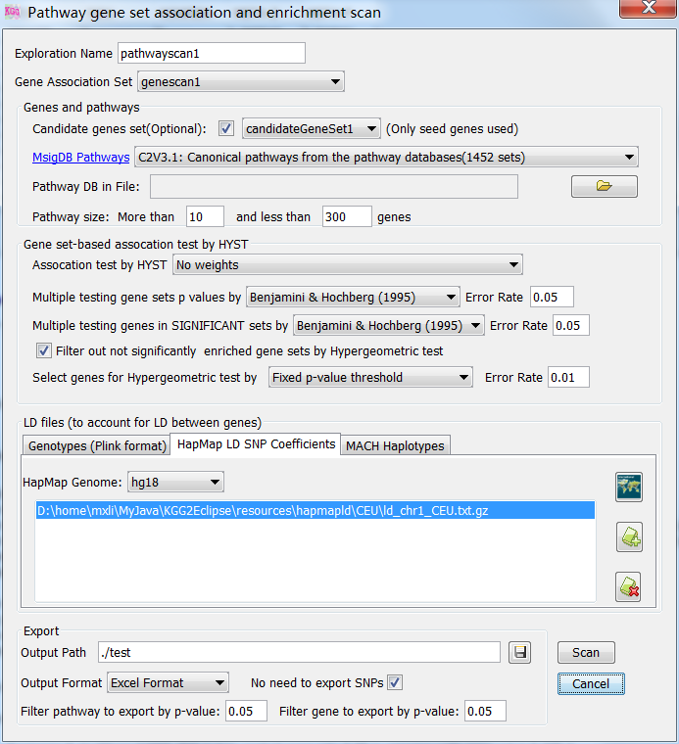

- Protein-protein interaction-based association analysis by HYST (~1 min.) Module->Protein interaction-based Association
